**Industrial Internship Report on**

**”Quality Prediction in a Mining Process”**

**Prepared by**

**Syed Mustafa Ayaan Ali**

|  |
| --- |
| *Executive Summary* |
| This report provides details of the Industrial Internship provided by upskill Campus and The IoT Academy in collaboration with Industrial Partner UniConverge Technologies Pvt Ltd (UCT).  This internship was focused on a project/problem statement provided by UCT. We had to finish the project including the report in 6 weeks’ time. My project was (Quality Prediction in a Mining Process and Multi-stage continuous-flow manufacturing process) This internship gave me a very good opportunity to get exposure to Industrial problems and design/implement solution for that. It was an overall great experience to have this internship. |

**ABLE OF CONTENTS**

1 Preface 3

2 Introduction 4

2.1 About UniConverge Technologies Pvt Ltd 4

2.2 About upskill Campus 8

2.3 Objective 9

2.4 Reference 9

2.5 Glossary 10

3 Problem Statement 11

4 Existing and Proposed solution 12

5 Proposed Design/ Model 13

5.1 High Level Diagram (if applicable) 13

5.2 Low Level Diagram (if applicable) 13

5.3 Interfaces (if applicable) 13

6 Performance Test 14

6.1 Test Plan/ Test Cases 14

6.2 Test Procedure 14

6.3 Performance Outcome 14

7 My learnings 15

8 Future work scope 16

# 

# 1. Preface

A data science internship can be the first step to starting a career as a professional. Offering hands-on experience in the work world, internships can provide networking opportunities, give you the chance to work with complex data sets, collaborate in a team environment, and experience the direct impact of your field of study.

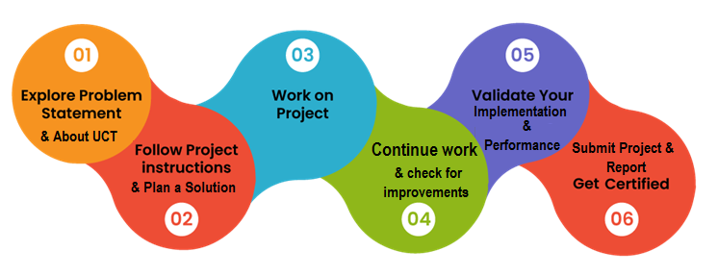Internships offer many potential benefits, including the opportunity to gain work experience, practice your technical skills in the real world, and build out your resume to help you as you set out on your career path.

Thank you to upskill campus and IoT technology for reference and helped throughout the internship.

**Message to juniors and peers** :

Typically lasting for a fixed amount of time, such as two months, internships also allow students and early career professionals an opportunity to connect with a network of industry professionals. In some cases, an internship might even lead directly to a job later.so it is very important for every junior to take the risk of practical exposure to get benefitted

# 2.Introduction

## 2.1 About UniConverge Technologies Pvt Ltd

A company established in 2013 and working in Digital Transformation domain and providing Industrial solutions with prime focus on sustainability and RoI.

For developing its products and solutions it is leveraging various**Cutting Edge Technologies e.g. Internet of Things (IoT), Cyber Security, Cloud computing (AWS, Azure), Machine Learning, Communication Technologies (4G/5G/LoRaWAN), Java Full Stack, Python, Front end**etc.

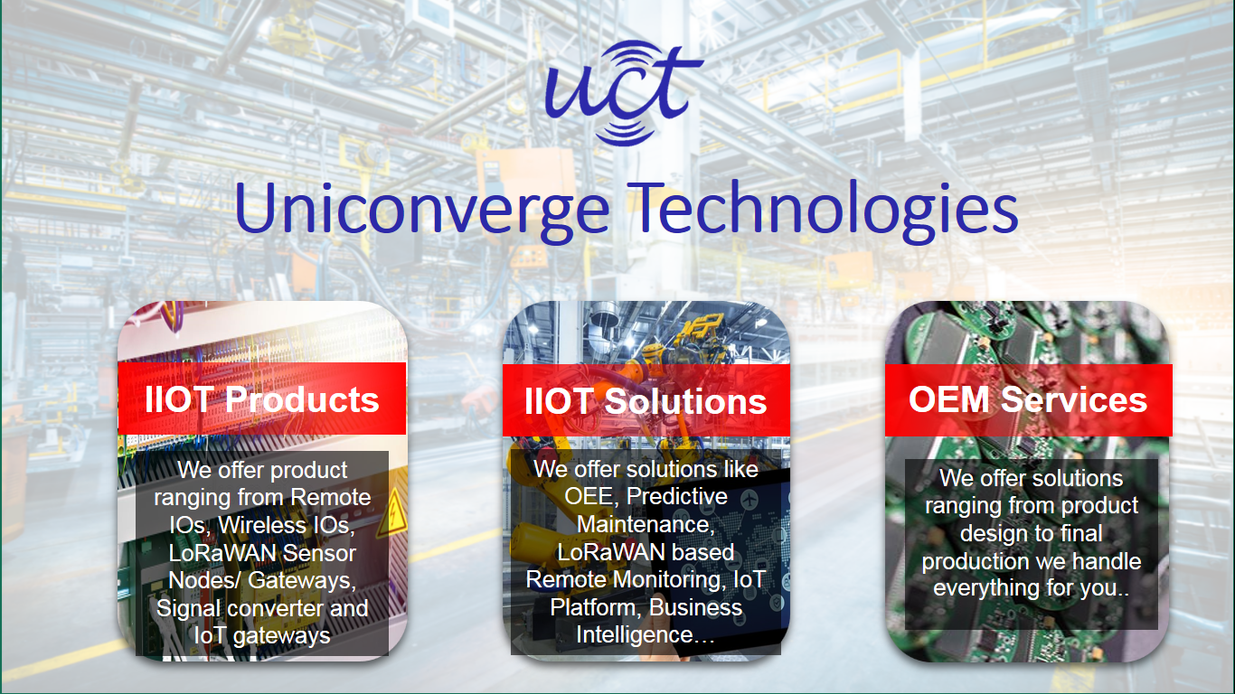

1. UCT IoT Platform **(****)**

**UCT Insight** is an IOT platform designed for quick deployment of IOT applications on the same time providing valuable “insight” for your

process/business. It has been built in Java for backend and ReactJS for Front end. It has support for MySQL and various NoSql Databases.

* It enables device connectivity via industry standard IoT protocols - MQTT, CoAP, HTTP, Modbus TCP, OPC UA
* It supports both cloud and on-premises deployments.

It has features to  
 • Build Your own dashboard  
 • Analytics and Reporting  
 • Alert and Notification  
 • Integration with third party application (Power BI, SAP, ERP)  
 • Rule Engine

 

1. **Smart Factory Platform (****)**

Factory watch is a platform for smart factory needs.

It provides Users/ Factory

* with a scalable solution for their Production and asset monitoring
* OEE and predictive maintenance solution scaling up to digital twin for your assets.
* to unleased the true potential of the data that their machines are generating and helps to identify the KPIs and also improve them.
* A modular architecture that allows users to choose the service that they what to start and then can scale to more complex solutions as per their demands.

Its unique SaaS model helps users to save time, cost and money.



1. 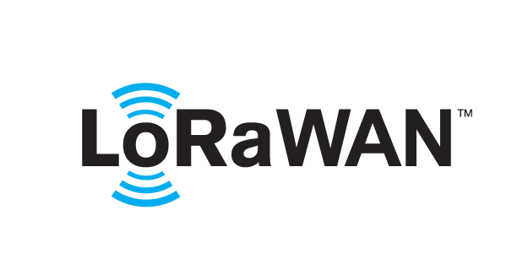 based Solution

UCT is one of the early adopters of LoRAWAN teschnology and providing solution in Agritech, Smart cities, Industrial Monitoring, Smart Street Light, Smart Water/ Gas/ Electricity metering solutions etc.

1. Predictive Maintenance

UCT is providing Industrial Machine health monitoring and Predictive maintenance solution leveraging Embedded system, Industrial IoT and Machine Learning Technologies by finding Remaining useful life time of various Machines used in production process.



## About upskill Campus (USC)

upskill Campus along with The IoT Academy and in association with Uniconverge technologies has facilitated the smooth execution of the complete internship process.

USC is a career development platform that delivers **personalized executive coaching** in a more affordable, scalable and measurable way.



<https://www.upskillcampus.com/>

upSkill Campus aiming to upskill 1 million learners in next 5 year

Seeing need of upskilling in self placed manner along-with additional support services e.g. Internship, projects, interaction with Industry experts, Career growth Services

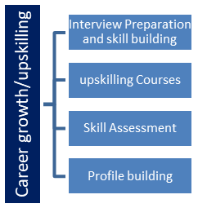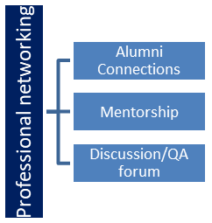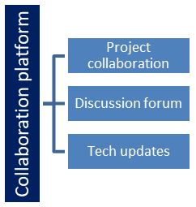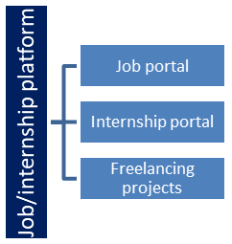

## The IoT Academy

The IoT academy is EdTech Division of UCT that is running long executive certification programs in collaboration with EICT Academy, IITK, IITR and IITG in multiple domains.

## Objectives of this Internship program

The objective for this internship program was to

 ☛ get practical experience of working in the industry.

 ☛ to solve real world problems.

 ☛ to have improved job prospects.

 ☛ to have Improved understanding of our field and its applications.

 ☛ to have Personal growth like better communication and problem solving.

## Reference

[1] Through Linkedln

[2] Reference from friend

[3] Through College Email Id

# Problem Statement

## 

* Import required modules
* Load the dataset.
* Display the data and constraints of the loaded dataset.
* Use different methods to visualize various illustrations from the data.

## Code submission (Github link):

## <https://github.com/syedayaan817/upSkill_Projects/blob/main/QualityMining.ipynb>

## Report submission (Github link):

<https://github.com/JaganmohanReddy26/Prediction-of-Crop-Production/blob/main/Project%20Report%20-%20Prediction%20of%20Agriculture%20Crop%20Production.docx>

**4. Existing and Proposed solution**

There are a lot of python libraries which could be used to build visualization like *matplotlib, vispy, bokeh, seaborn, pygal, folium, plotly, cufflinks*, and *networkx*. Of the many, *matplotlib* and *seaborn* seems to be very widely used for basic to intermediate level of visualization.

Exploratory data analysis

Heat maps to check null/missing values

# 5.Proposed Design/ Model

Given more details about design flow of your solution. This is applicable for all domains. DS/ML Students can cover it after they have their algorithm implementation. There is always a start, intermediate stages and then final outcome.

## High Level Diagram (if applicable)

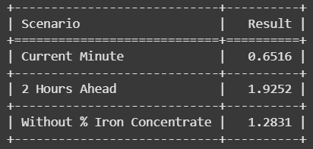

Final Results

Figure 1: HIGH LEVEL DIAGRAM OF THE SYSTEM

## Low Level Diagram (if applicable)

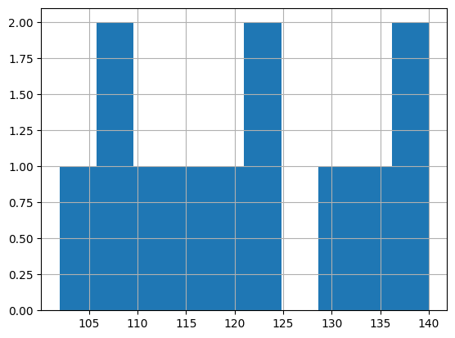

Histogram graph using the given data for model evaluation

## Interfaces (if applicable)

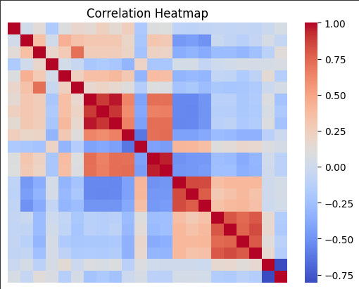

# 6. Performance Test

Performance testing can involve quantitative tests done in a lab or in production environments. In performance tests, requirements should be identified and tested. Typical parameters include processing speed, data transfer rates, network bandwidth and throughput, workload efficiency and reliability.

## Test Plan/ Test Cases

* What needs to be the tested-the scope of testing, including clear identification of what will be the tested & what will not be tested.
* How the testing is going to be performed – breaking down the testing into small and manageable tasks and identifying the strategies to be used for carrying out the tasks.
* Resource needed for testing
* The timelines by which the testing activities will be performed.
* Risks that may be faced in all of the above, with appropriate mitigation and contingency plans.
* Using the test plan as the basis, the testing team design test case specification which then becomes the basis for preparing for individual test cases.
* A test case is nothing but a series of step executed on a product, using a predefined set of input data, expected to produce a pre-defined set of outputs, in a given environment.
* It describes “how” to implement those test cases.
* Test case specifications are useful as it enlists the specification details of the items.

**6.2 Test Procedure**

1. Create the development, validation and testing data sets.
2. Use the training data set to develop your model.
3. Compute statistical values identifying the model development performance.
4. Calculate the model results to the data points in the validation data set.
5. Compute statistical values comparing the model results to the validation data.
6. Calculate the model results to the data points in the testing data set.
7. Compute statistical values comparing the model results to the test data

## Performance Outcome

* **Accuracy**
* **Misclassification Rate (MISC)**
* **Precision**
* **Recall**
* **Specificity**
* **F-1 Score**
* **Receiver Operating Characteristics and Area Under the Curve**
* **Cumulative Accuracy Profile**

# 

# 7. My learnings

A data science internship can mark the beginning of a new career. To prepare for this next phase of my professional life.

If you are interested in a career in Data Science, you must have strong computer programming skills, statistics, and machine learning. You should also effectively communicate your findings to non-technical audiences. Data Science is an exciting and rapidly growing field that offers many opportunities for career advancement.

I had clearly understood the topics like Big Data, Definition of Data Science and Machine Learning, and its uses, applications and life cycle, process etc.

With so many Real-life examples you had made us to understand so well in a proper manner.

As videos are recorded one, so that one who can’t understand the topic can able to refer the videos again.

Clear road map had provided.

A very good opportunity for beginners like us.

Apart from videos, links and pdfs had provided.

Clear explanation. And also it is better for us if you provide some basic concepts of programing languages which are needed for data science.

Through IoT academy everyone can gain the knowledge. best platform for beginners and learners too.

# 

# Future work scope

* Data Science is essential for organizations, especially because organizations now understand the value it brings. Here are the key responsibilities of a data scientist: The data scientist’s future scope is widening, and it will continue to open greater opportunities due to the increasing demand for skilled professionals.
* As more organizations recognize the value of data science, they are turning to India for help building their data science capabilities.
* Data Science encompasses many breakthrough tech concepts like Artificial Intelligence, Internet of Things, Deep Learning to name a few. With its progress and technological developments, data science’s impact has increased drastically.

I thank UpSkill campus which is in partnership with its industrial partner UniConverge Technologies (UCT) has brought Internship program, for providing this opportunity of great learning experience. I thank IoT academy for providing the references and being part of this internship.

Thank You

@UpSkill Campus

@IoT Academy

@UniCoverge Technologies